A. MULTIPLE CHOICE (8.0 points)

Mark the letter A, B, C or D to indicate the word whose underlined part differs from the other three in pronunciation in each of the following questions.
Question 1: A. learn | B. wear | C. earn | D. heard
Question 2: A. enjoyed | B. designed | C. cried | D. laughed
Mark the letter A, B, C, or D to indicate the word that differs from the other three in the position of primary stress in each of the following questions.
Question 3: A. enormous | B. generous | C. difficult | D. popular
Question 4: A. geography | B. minority | C. priority | D. inspiration

Mark the letter A, B, C or D to indicate the correct answer to each of the following questions.
Question 5: We eat rice nearly every day, and rice in many areas of Asia.

A. is grown | B. are grown | C. was grown | D. were grown
Question 6: is the study of the Earth's physical features and the people, plants and animals that live in different regions of the world.
A. History | B. Physics | C. Technology | D. Geography
Question 7: The weather was very nice, they decided to have breakfast in the garden.

A. therefore | B. so | C. but | D. although
Question 8: Before you leave the room, don’t forget to the lights to save energy.

A. turn off | B. turn on | C. look for | D. look after
Question 9: The boy is counting the money as lucky money.

A. which he received | B. which he received it | C. he received it | D. who he received
Question 10: We all hate .

A. laughing at | B. being laughed at | C. being laughed for | D. laughing for
Question 11: There are some risks when we use the Internet, ?

A. aren’t they | B. are they | C. are there | D. aren’t there
Question 12: It was that our team lost the match 2- 0.

A. interesting | B. interested | C. disappointing | D. disappointed
Question 13: I have had a very good time with you. I wish I have to say goodbye to you now.

A. don’t | B. didn’t | C. won’t | D. will
Question 14: His doctor suggests that he some weight.

A. losing | B. lost | C. should lose | D. to lose
Question 15: I’m not a good guitar player. If I the guitar well, I would accompany your singing.

A. plays | B. can play | C. play | D. played
Question 16: People in this ethnic village the Water God.

A. worship | B. watch | C. perform | D. learn
Question 17: They are old enough to be for what they have done.

A. responsibly | B. responsibility | C. responsible | D. irresponsible

Mark the letter A, B, C or D to indicate the most suitable option to complete the following exchange.
Question 18: Jane is telling Tom about her exam.
Jane : “ .”
Tom : “That's great. Congratulations!”

A. I hope I'll pass the exam tomorrow. | B. I've passed the exam.
C. I'll get the exam results tomorrow. | D. I didn't do very well in the exam.

Mark the letter A, B, C or D to indicate the underlined part that needs correction in each sentence.
Question 19: Linda asked Kenlly whether did she like sports or not.

A. or not | B. did she like | C. whether | D. asked
Question 20: They are moving to Lang Son, that is in northern Vietnam.

A. northern | B. is moving | C. to | D. that

Mark the letter A, B, C, or D to indicate the word(s) CLOSEST in meaning to the underlined word in each of the following questions.
Question 21: American children customarily go trick-or-treating on Halloween.

A. traditionally | B. readily | C. happily | D. widelly

Mark the letter A, B, C, or D to indicate the word(s) OPPOSITE in meaning to the underlined word in each of the following questions.
Question 22: With price increases on food and other necessities, many people have to tighten their belt.

A. spend money thoughtfully | B. save on daily expenses
C. spend money freely | D. put on tighter belts

Read the following passage and mark the letter A, B, C or D to indicate the correct word that best fits each of the numbered blanks from 23 to 27.
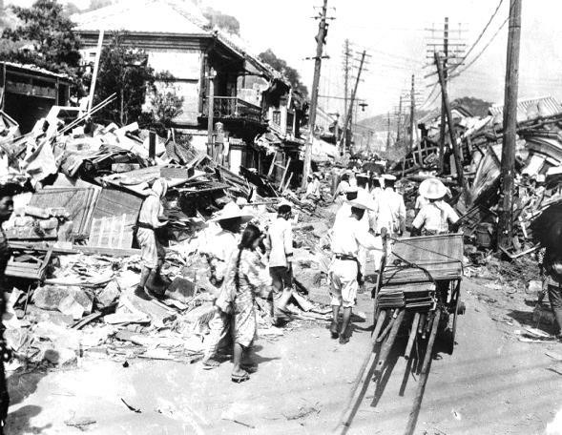
Almost a hundred thousand people were killed and half a million homes (23) as a result of an earthquake in Tokyo in 1923. The earthquake began a minute before noon when the people of Tokyo were cooking their midday meals. Thousands of stoves were (24) as soon as the earth began to shake. As a result, small fires broke out everywhere and quickly spread. The fire engines were prevented (25) to help because many of the roads had cracked open. It was (26) to use fire fighting equipment as most of the water pipes had burst.
Consequently, over ninety percent of the damage was caused by fire rather than by the collapse of buildings. Most of the people (27) were not killed in the earthquake itself but in the fires which followed.
Question 23: | A. were killed | B. were destroyed | C. killed | D. destroyed
Question 24: | A. overturned | B. collapsed | C. fallen down | D. fallen in
Question 25: | A. with going | B. for going | C. from going | D. to going
Question 26: | A. impossible | B. possible | C. able | D. unable
Question 27: | A. whom died | B. which died | C. who died | D. died

Read the following passage and mark the letter A, B, C or D to indicate the correct answer to each of the questions 28 to 32.
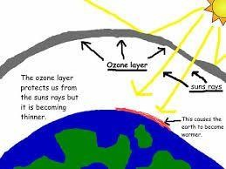
Today, I’d like to begin a discussion on the problem of the heating up of the earth. First, we’ll touch on the relationship between fluorocarbons and the ozone layer. You probably remember that the ozone layer is the protective shield around the earth. It is important to all life, because it filters out harmful ultraviolet light from the sun. Ozone itself, a form of oxygen, is regularly destroyed by natural chemical processes.
The problem now is that too much of the ozone layer is being destroyed. Scientists suspect that certain chemicals, such as fluorocarbons, are contributing to the depletion of the ozone layer. And how do we use fluorocarbons? The most common uses are in spray cans and cooling systems. The chemical pollution from these fluorocarbons can account for some of the ozone losses that have been reported. There are, however, new studies linking the sun itself to the depletion of the ozone layer. We’ll go into that new study next time.
Question 28: The speaker is very likely to be .

A. a doctor | B. a mechanic | C. a chemist | D. a professor
Question 29: The speaker’s main topic is .
A. ultraviolet light and fluorocarbons B. fluorocarbons and the ozone layer
C. air-conditioning systems D. the use of spray cans
Question 30: The phrasal verb filters out from the 1st paragraph is closest in meaning to .

A. prevents | B. produces | C. collects | D. releases
Question 31: What is the most important function of the ozone layer?
A. To protect the earth B. To produce fluorocarbons
C. To shield the sun D. To destroy natural chemicals
Question 32: What will the speaker probably discuss next time?
- How air conditioners produce fluorocarbons B. Harmful effects of ultraviolet light
C. The sun as a cause of ozone layer depletion D. The make-up of the ozone layer

WRITING (2.0 points)

Finish the second sentence in such a way that it means exactly the same as the sentence given.
Question 33: The last time I texted her was about three months ago.
→ I haven’t………………………………………………………………………………………………………………………………….
Question 34: Visitors to the zoo mustn’t feed the animals.
→ The animals …………………………………………………………………………………………….....……………………………
Question 35: I advise you not to spend much time on computer games.
→ If I……………………………..…………………………………………………………………………………………………................
Question 36: Although the written test was long, we managed to finish it on time.
→ In spite of…………………………………..………………………………………………………………………………………………

- THE END -

