Giải bài tập Unit 11 Skills 2 tiếng Anh 6 sách Kết nối tri thức giúp các em học tốt Tiếng Anh 6.

Giải bài tập Tiếng Anh 6 Unit 11 Skills 2
Thực hiện các yêu cầu của sách giáo khoa khi giải bài tập Tiếng Anh 6 Kết nối tri thức tập 2 trang 55 về nghe và viết.

Listening
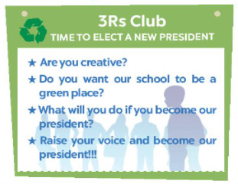

I. Listen to two students talking about what they will do if the become the presidents of thr 3Rs club. Fill each blank with a word or a number.
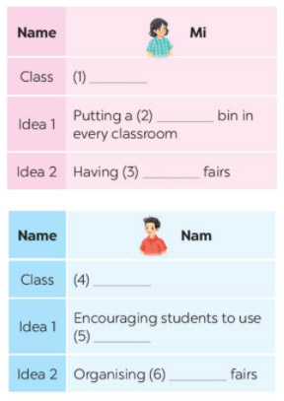
Answer
(1) 6A
(2) recycling
(3) book
(4) 6E
(5) bus
(6) uniform

II. Listen and tick T (True) of F (False)
 | T | F
1. Mi thinks they can recycle things in the bins.
2. Tat book fairs, students can exchange their old books.
3. Nam thinks students will save money if they go to school by bus.
4. Students can exchange their used uniform at uniform fairs.
Answer
1. F (resuse things)
2 T
3. F ( it helps the enviroment)
4. T
Audio script
Mi: I'm Mi from class 6A. If I become the president of the Club. I'll first talk to my friends about putting a recycling bin in every classroom. We can reuse the things we have in these bins. Secondly, I'll organise some book fairs. Students can exchange their used books at these fairs.
Nam: I'm Nam from class 6E. If I become the president of the Club, I'll be fun and help the enviroment. Next, I'll organise some uniform fairs. This is where students can exchange used uniforms with other students.

Writing

III. Interview a classmate. Ask him / her what two things he / she will do if he / she becomes the president of the 3Rs Club. Take notes below.
Name ....................................................
Idea 1 ...................................................
Idea 2 ...................................................
Study Skill - Writing
Giving explanations and / or examples is an Important writing skill You should give explanations and / or examples to support your ideas.
Example:
Secondly, I'll organize some book fairs. At these events students can exchange their used books.
Answer
Name: Phuong Thao
Idea 1: Organize a charity, students will give their old uniforms or clothes for her Charity at every weekend. She will give these things to those in need
Idea 2: Establish a team can walk to school or cycle to school to reduce dirty air

V. Write a paragraph about your classmate’s ideas in 5. Write about 50 words.
Answer
My classmate is Phuong Thao.
If she becomes the president of the 3Rs Club, she will do two things. Firstly, she will organize a charity, students will give their old uniforms or clothes for my charity at every weekend. She will give these things to those in need. Secondly, she will establish a team can walk to school or cycle to school to reduce dirty air.
-/-
Giải bài tập Tiếng Anh 6 Unit 11: Our Greener world - Skills 2 sách Kết nối tri thức do Đọc tài liệu tổng hợp, hi vọng sẽ giúp các em học tốt môn Tiếng Anh 6 thật thú vị và dễ dàng.

