Giải bài tập Unit 10 Skills 2 tiếng Anh 6 sách Kết nối tri thức giúp các em học tốt Tiếng Anh 6.

Giải bài tập Tiếng Anh 6 Unit 10 Skills 2
Thực hiện các yêu cầu của sách giáo khoa khi giải bài tập Tiếng Anh 6 Kết nối tri thức tập 2 trang 45 về nghe và viết.

Listening

I. Listen to Nick and Linda talking about their dream houses. Which house would each prefer? Write their names under the correct pictres
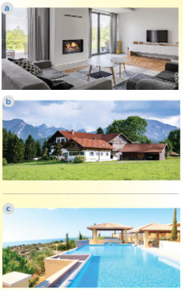
Answer
- Nick - a
- Linda - c

II. Listen to the conversation again. What is important to Nick? Tick the columns
 | Linda | Nick
1. park view
2. city view
3. sea view
4. swimming pool
5. garden
Answer
- Linda: 3, 4, 5
- Nick: 1,2, 6

III. Listen again and answer the questions about their dream houses.
1. What type of house does Linda have?
2. Where is her house?
3. What is around her house?
4. What type of house does Nick have?
5. Where is it?
6. What appliances does it have?
Answer
1. She has a big villa
2. Her house/It's by the sea
3. There's a swimming pool and a garden around her house.
4. He has a flat
5. It's in the city
Audio script
Nick: Can you tell me about your dream house, Linda?
Linda: Well, it's a big villa by the sea. It has a view of the sea. It has a swimming pool and a garden.
Nick: My dream houses is different.
Linda: Really? What's it like?
Nick: It's a beautiful flat in the city. It has a park view in front and a city view at the back.
Linda: Oh, sounds great!
Nick: It has a super smart TV. I can watch films from other planets.
Linda: That sounds great, too. But I think it'll be....

Writing

IV. Work in pairs. Discuss your dream house, and fill the table.
Example:
A: What type of dream house is it?
B: It's a palace.
A Where is it?
B: It's in the mountains.
Answer
A: what type of dream house is it?
B: It's a villa
A: Where is it?
B: It's on the coast
A: How many rooms will it have?
B: It has 8 rooms
A. What appliances wil it have ?
B: There will be a smatrt TVs, a modern fridge, a vaccum cleaner...

V. Use the information in 4 to write a paragraph of about 50 words about your dream house.
Example:
My dream house is a big palace. It is in the mountains....
Answer
My dream house is a big palace. It is in the mountains. It is surrounded by lots of trees. It has seven rooms: three bedrooms, two bathrooms, one kitchen and one livingroom. There is a large swimming pool in front of it. I have some robots in the palace. They help me to clean the floor, cook meals, water flowers.... I'm happy to live in my palace.
-/-
Giải bài tập Tiếng Anh 6 Unit 10: Our houses in the future - Skills 2 sách Kết nối tri thức do Đọc tài liệu tổng hợp, hi vọng sẽ giúp các em học tốt môn Tiếng Anh 6 thật thú vị và dễ dàng.

