Giải bài tập Unit 9 A Closer look 2 tiếng Anh 6 sách Kết nối tri thức giúp các em học tốt Tiếng Anh 6.

Giải bài tập Tiếng Anh 6 Unit 9 A Closer look 2
Thực hiện các yêu cầu của sách giáo khoa khi giải bài tập Tiếng Anh 6 Kết nối tri thức tập 2 trang 29-30 về ngữ pháp.

Possessive adjectives
Remmember
A possessive adjectives is used only when there's a noun following it.
Pronouns | Possessive adjectives | Possessive pronouns
I  you  he  she  it  we  they | my  your  his  her  its  our  their | mine  yours  his  hers  its  ours  theirs
Example:
I have a pen = > This is my pen.

I. Match the sentences with the pictures, paying atttention to the underlined part in each sentence.
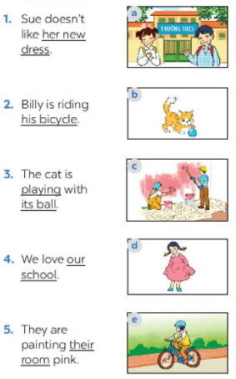
Answer
1. d
2. e
3. b
4. a
5. c

II. Complete the sentences with the correct possessive adjectives.
1. I love cartoons. ............favourite cartoon is Dragon Balls.
2. This book has your name on it. Is it .................. book?
3. The lion has three cubs. ............ cubs are playing under a big tree.
4. Do you know my friend Anna? .................. house is close to the park.
5. We are from Switzerland. ................. country is famous for chocolate.
Answer
1. My
=> I love cartoons. My favourite cartoon is Dragon Balls.
2. Your
=> This book has your name on it. Is it your book?
3. Its
=> The lion has three cubs. Its cubs are playing under a big tree.
4. Her
=> Do you know my friend Anna? Her house is close to the park
5. Our
=> We are from Switzerland. Our country is famous for chocolate.

Possessive pronouns
Remmember
A possessive pronouns is used alone without a noun following it.
Example
This book is my book, not your book.
=> This book is mine, not yours.

III. Complete the sentences with the correct possessive pronouns.
1. I have a new bike. The bike is ........
2. These are Mai's and Lan’s maps. These maps are .......
3. This is a present for you. It's ..........
4. My father has new shoes. They're ...........
5. This is our new house. The house is ..............
Answer
1. mine
=> I have a new bike. The bike is mine.
2. theirs
=> These are Mai's and Lan’s maps. These maps are theirs.
3. yours
=> This is a present for you. It's yours.
4. his
=> My father has new shoes. They're his.
5. ours
=> This is our new house. The house is ours.

IV. Underline the correct word in brackets to complete each sentence.
1. Australia is a strange country.
All of (it's / its) big cities are along the coast.
2. Our city is very crowded. How about (your / yours)?
3. I love my football club. Does Phong like (his / him)?
4. (Our / Ours) street is short and narrow.
5. They cannot find (their / theirs) city map anywhere.
Answer
1. its
2. yours
3. his
4. our
5. their

V. Choose the correct word to complete the sentences.
1. The book is....., but you are welcome to read it
A. my
B. mine
C. yours
2. ... bike is dirty, and I can't tell what colour it is.
A. Your
B. Yours
C. You
3. Your country is much bigger than ....
A. our
B. ours
C. their
4. .... dog is so friendly. It never barks.
A. They
C. Their
D. Theirs
5. .... not easy to find your way in a strange city.
A. It
B. It's
C. Its
Answer
1. Mine
2. Your
3. Ours
4.Their
5. It's
-/-
Giải bài tập Tiếng Anh 6 Unit 9: Cities of the world - A closer look 2 sách Kết nối tri thức do Đọc tài liệu tổng hợp, hi vọng sẽ giúp các em học tốt môn Tiếng Anh 6 thật thú vị và dễ dàng.

