Giải bài tập Unit 8 Skills 1 tiếng Anh 6 sách Kết nối tri thức giúp các em học tốt Tiếng Anh 6.

Giải bài tập Tiếng Anh 6 Unit 8 Skills 1
Thực hiện các yêu cầu của sách giáo khoa khi giải bài tập Tiếng Anh 6 Kết nối tri thức tập 2 trang 22 về đọc và nói.

Reading

I. Work in pairs. Discuss the questions
1. What do you know about Pele?
2. What is special about him?
Answer
1. Pele is a Brazil football player
2. He is the King of Football

II. Read the dialogue quickly to check your ideas in 1.
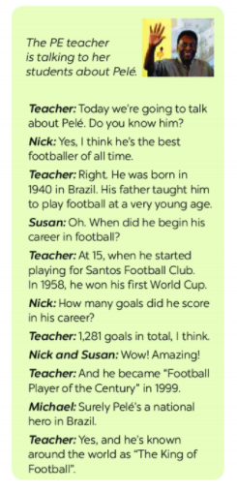

III. Read the text again and answer the questions.
1. When was Pelé born?
2. Who first taught him to play football?
3. How many goals did he score in total?
4. When did he become “Football Player of the Century"?
5. What do people call him?
Answer
1. Pele was born in 1940
2. His father did/ His father taught him.
3. He scored 1281 goals in total
4. (He became Football Player of the Century) In 1999
5. They call him "The King of Football".

Speaking

IV. Read the following facts about two famous sportspeople.
Hoang Giang - No. 1 sportsman in shooting
- Born: 1978 in Viet Nam
- 1995: finished sports school
- 1996 took part in a shooting competition
- 2001 won a gold medal for shooting
Jenny Green - one of the best female golfers in history
- Born: 1972 in Greenland
- 1987: becarne a member of local golf club
- 1994: took part ina female golf tournament
- 2002 became the female golf champion

V. Choose one sportsperson in 4. Talk about him / her. Use the following cues.
- His / Her name
- The sport he/ she plays
- Why he / she is famous
- You like him / her or not. Explain why.
Answer
- His name is Hoang Giang, he was born in 1978 in Viet Nam. He plays shooting. He is famous for being No.1 sportsman in shooting. In 1996, he took part in a shooting competition. In 2001, he won a medal for shooting.
- Her name is Jenny Green. She was born in 1972 in Greenland. She plays golf. She is famous for being one of the best female golfers in history. In 1987, she became a member of local golf club. In 1994, she took part in a female golf tournament and in 2002, she became the female golf champion.
-/-
Giải bài tập Tiếng Anh 6 Unit 8: Sports and Games - Skills 1 sách Kết nối tri thức do Đọc tài liệu tổng hợp, hi vọng sẽ giúp các em học tốt môn Tiếng Anh 6 thật thú vị và dễ dàng.

