Giải bài tập Unit 8 A Closer look 2 tiếng Anh 6 sách Kết nối tri thức giúp các em học tốt Tiếng Anh 6.

Giải bài tập Tiếng Anh 6 Unit 8 A Closer look 2
Thực hiện các yêu cầu của sách giáo khoa khi giải bài tập Tiếng Anh 6 Kết nối tri thức tập 2 trang 19-20 về ngữ pháp.
The past simple
Remmember
We use the past simple to talk about somthing that happened in the past.
Example: I played badminton with Phong yester day.
- Positive
I/You/We/They/He/She/It + V-ed(played)
- Negative
I/You/We/They/He/She/It + did not/didn't V(did not/didn't play)
- Questions and short answers
Did I/you/we/they/he/she/it + V(play)?
Yes, I/you/we/they/he/she/it did.
No, I/you/we/they/he/she/it didn't.

I. Choose the correct answer A,B, or C.
1. There ........... an interesting match on TV last night.
A. is
B. were
C. was
2. My dad ........... a lot of tennis some years ago.
A. plays
B. played
C. is playing
3. I was at the gym last Sunday, but I ............ you there.
A. not saw
B. don't see
C. didn't see
4. The teacher ............. us about our homework this moming.
A. didn’t ask
B. not asting
C. doesn't ask
5. .............. sleep weil last night?
A. Do you
B. Did you
C .Were you
Answer
1. C
=> There was an interesting match on TV last night.
2. B
=> My dad played a lot of tennis some years ago.
3. C
=> I was at the gym last Sunday, but I didn’t see you there.
4. A
=> The teacher didn’t ask us about our homework this moming.
5. B
=> Did you sleep well last night?

II. Write the correct form of the verbs to complete the conversation
Nick: Hi, there.
Sonny: Hello, Nick. Did you have a nice weekend?
Nick: Yeah, it was OK On Sunday, I (1. go).......... fishing with my dad. How about you?
Sonny: Oh, I (2. have).......... a good weekend, too.
Nick: Really? What ....... you (3. do) ?
Sonny: I (4. visit) ........... the museum with my family, then we (5. eat) ....... at my favourite restaurant
Nick: Did you watch football on Sunday?
Sonny: Oh, yeah! My favourite team (6. score) ................ fantastic goal
Answer
1. went
2. had
3. did you do
4. visited
5. ate
6. scored
Nick: Hi, there.
Sonny: Hello, Nick. Did you have a nice weekend?
Nick: Yeah, it was OK On Sunday, I went fishing with my dad. How about you?
Sonny: Oh, I had a good weekend, too.
Nick: Really? What did you do?
Sonny: I visited the museum with my family, then we ate at my favourite restaurant
Nick: Did you watch football on Sunday?
Sonny: Oh, yeah! My favourite team scored fantastic goal.

III. Work in groups. Ask and aswer questions about your last weekend
Example:
A: Did you do any sport last weekend?
B: Oh yes, and I was exhausted.
C: Really? What did you do?
...
Answer
Học sinh thực hành theo nhóm trên lớp.
Impertatives
Remmember
We use imperatives to tell someone to do something, or to give a direct order.
It's a chewing gum.
Chew it.
Don't swallow it.
- Positive: V
- Negative: Don't + V

IV. Look at each picture anf choose the correct answer
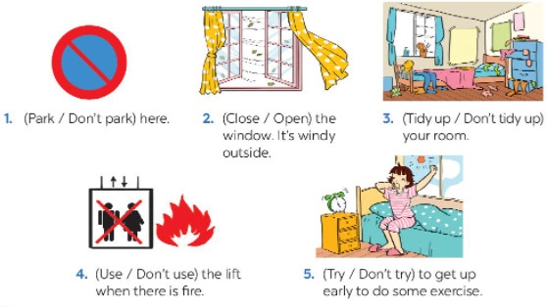
Answer
1. Don't park
2. Close
3. Tidy up
4. Don't use
5. Try

V. Tell your friends what to do and what not to do at the gym
Examples:
- Change your clothes.
- Don't speak loudly.
...
Answer
* What to do
- Bring a lock to put your bag and personal items in the locker
- Warm up
- Do a beginner’s strength workout
- Try everything out
- Pay your fee first.
- Put on your trainers/sports shoes.
- Listern to the instructor carefully.
- Don't litter.
- Don't eat or drink at the gym.
-/-
Giải bài tập Tiếng Anh 6 Unit 8: Sports and Games - A closer look 2 sách Kết nối tri thức do Đọc tài liệu tổng hợp, hi vọng sẽ giúp các em học tốt môn Tiếng Anh 6 thật thú vị và dễ dàng.

