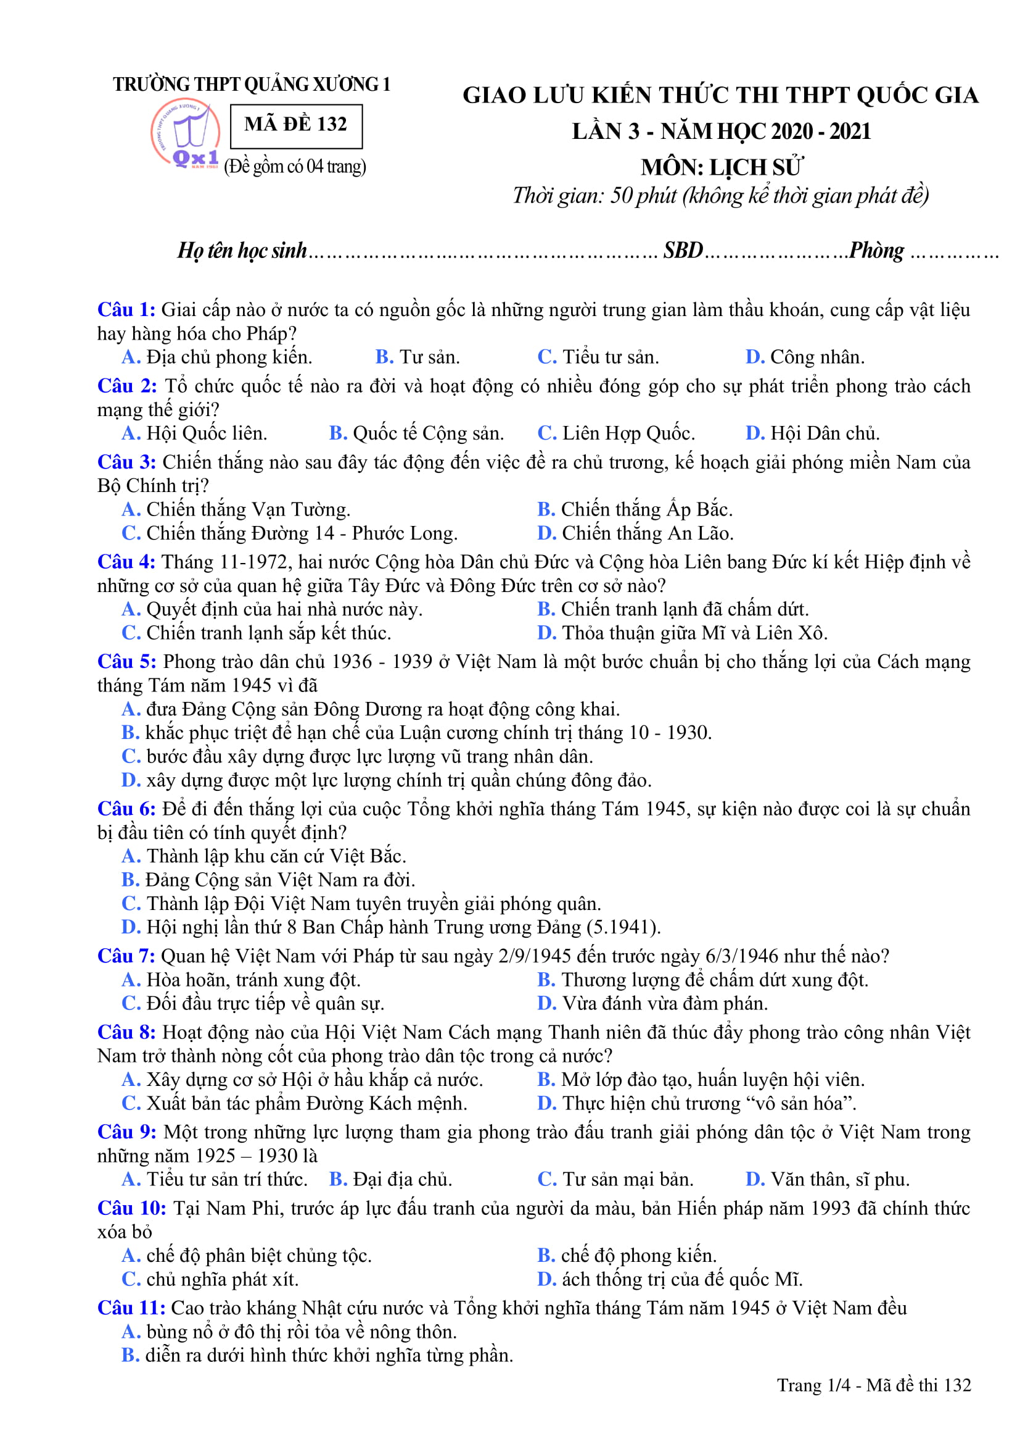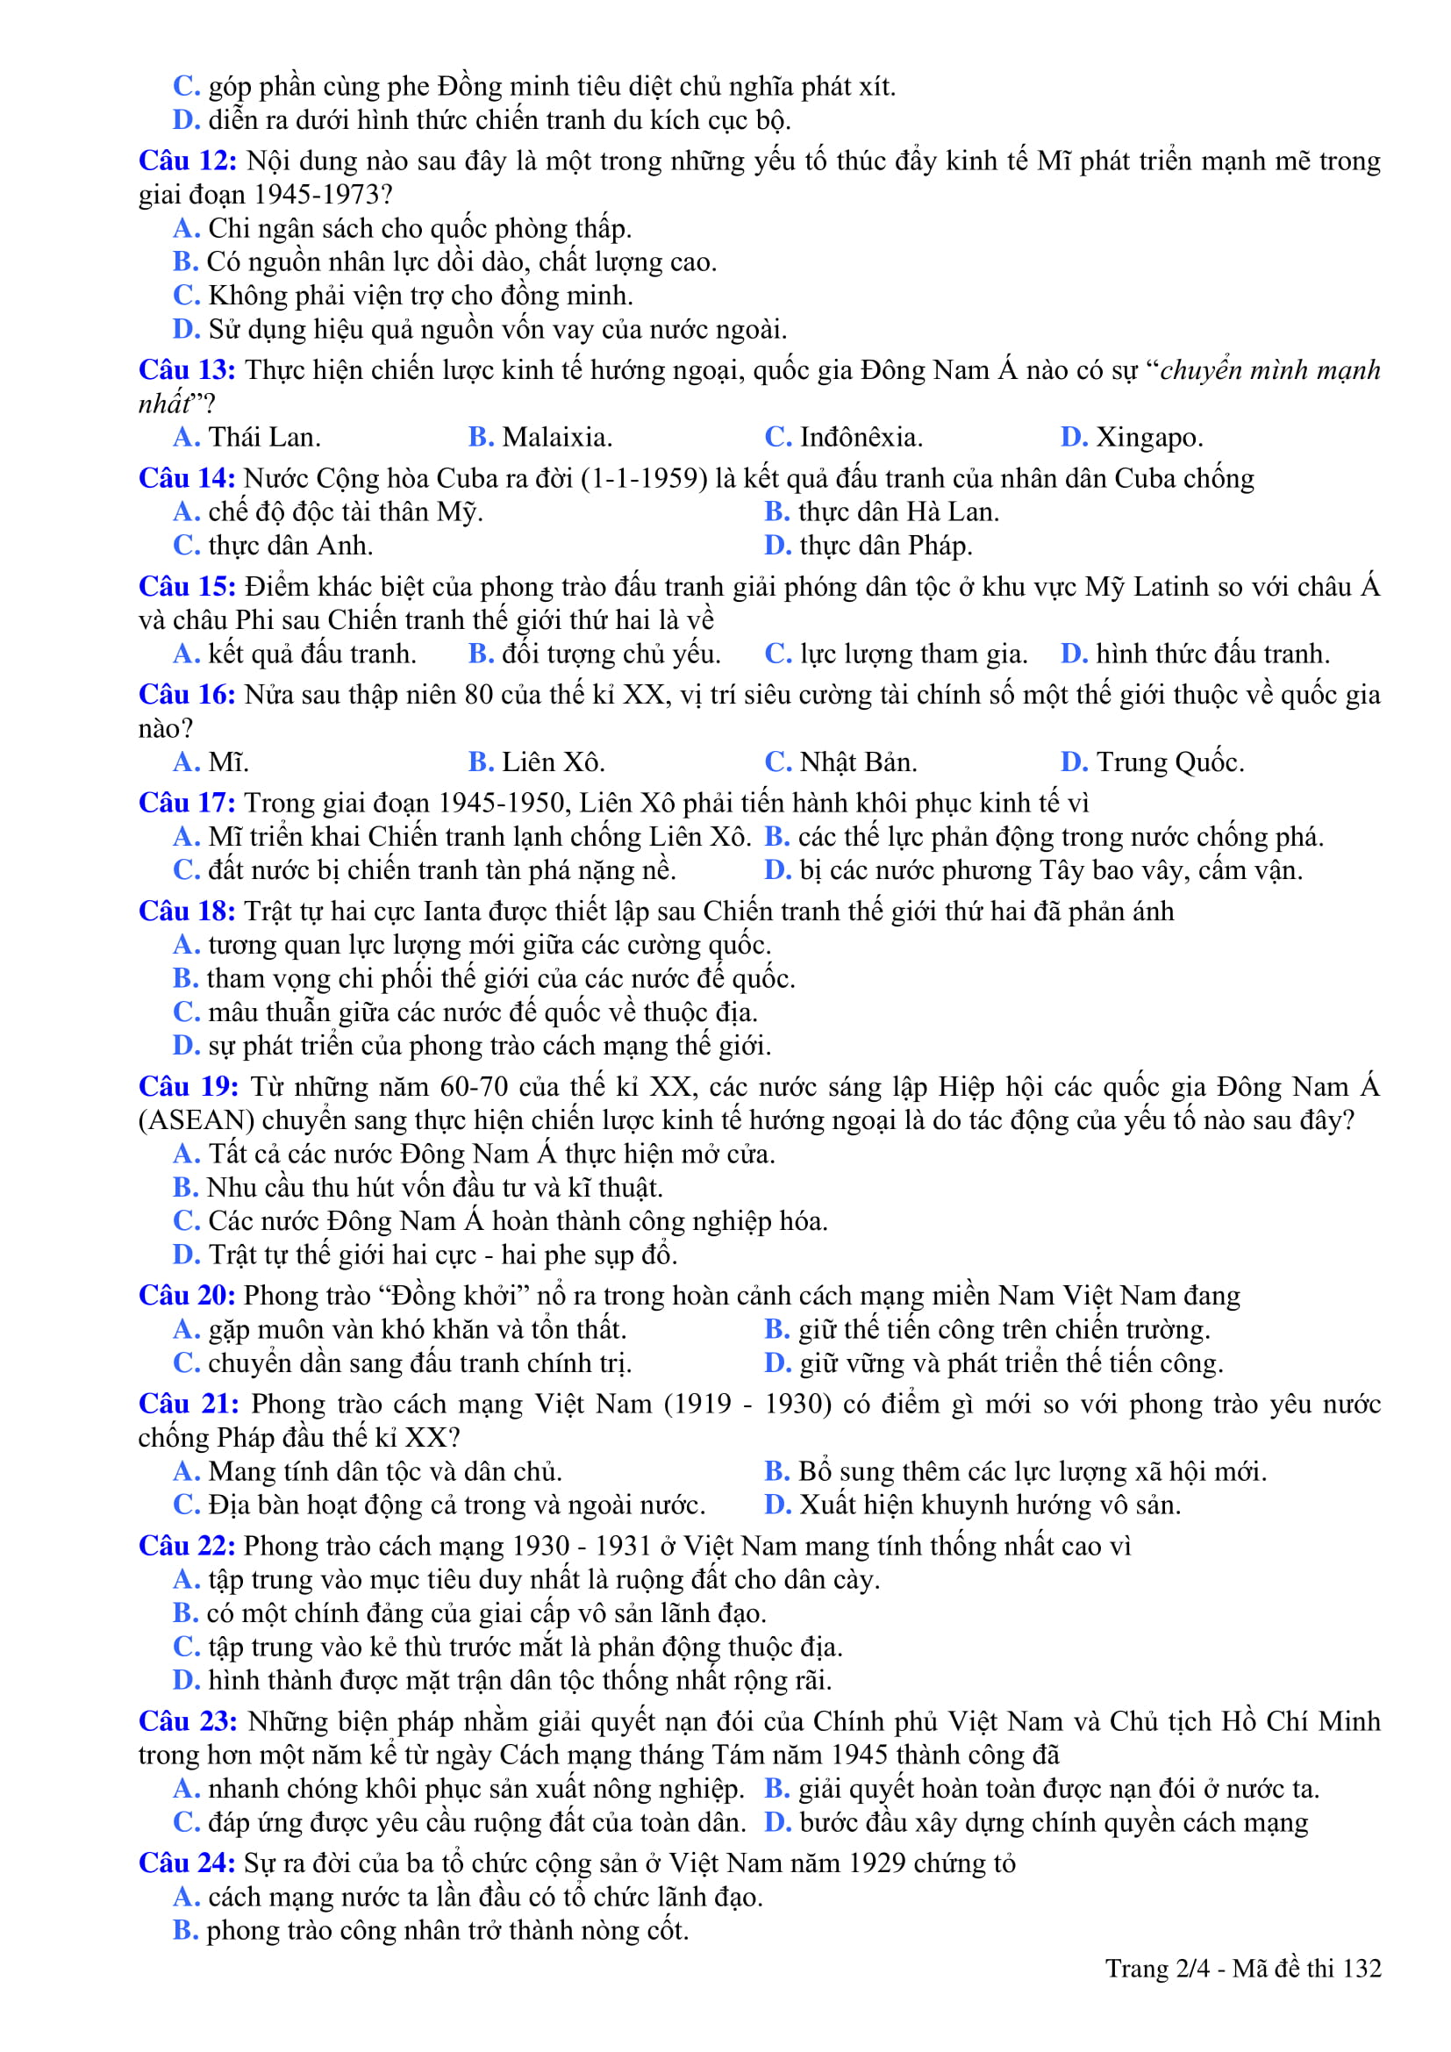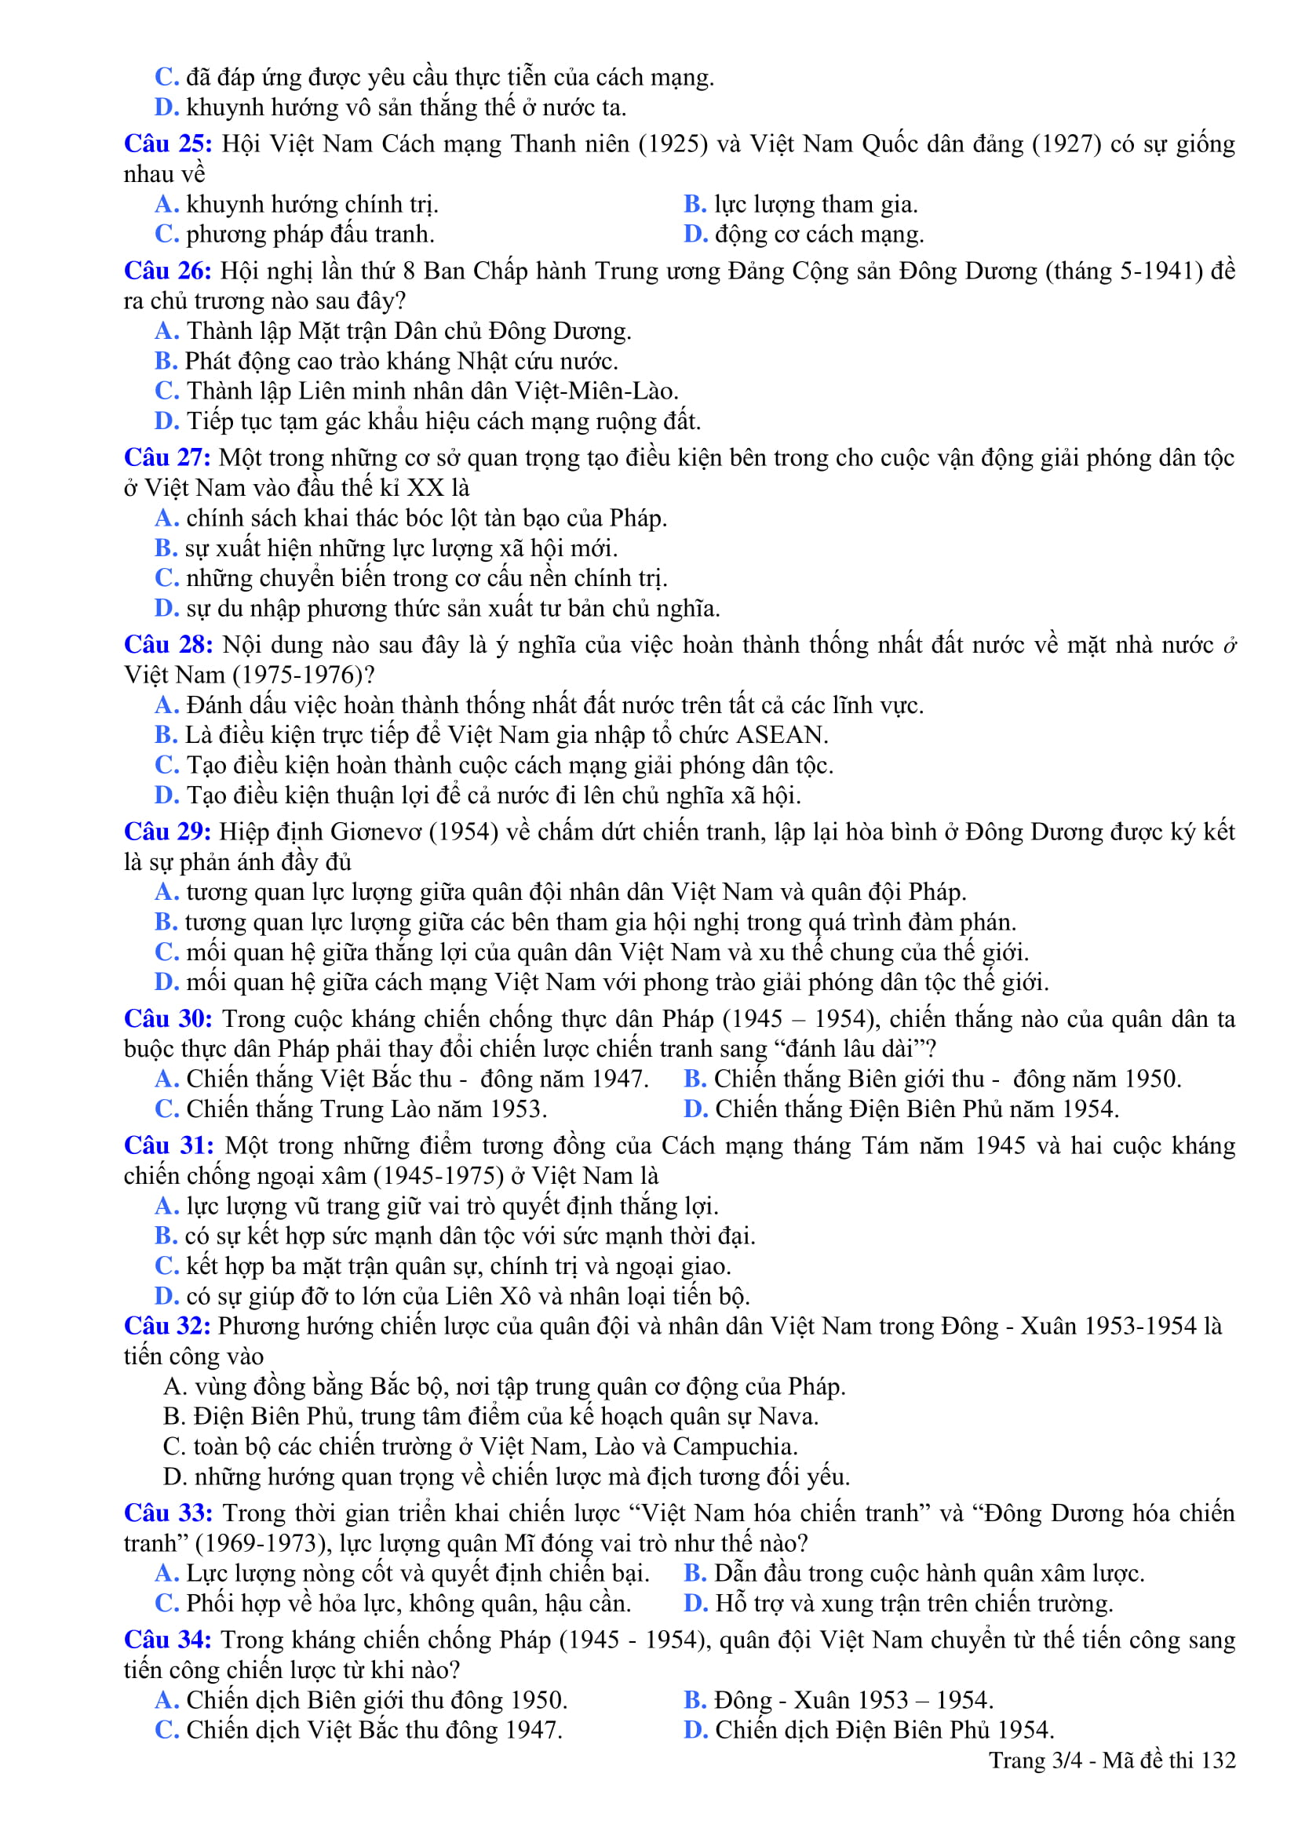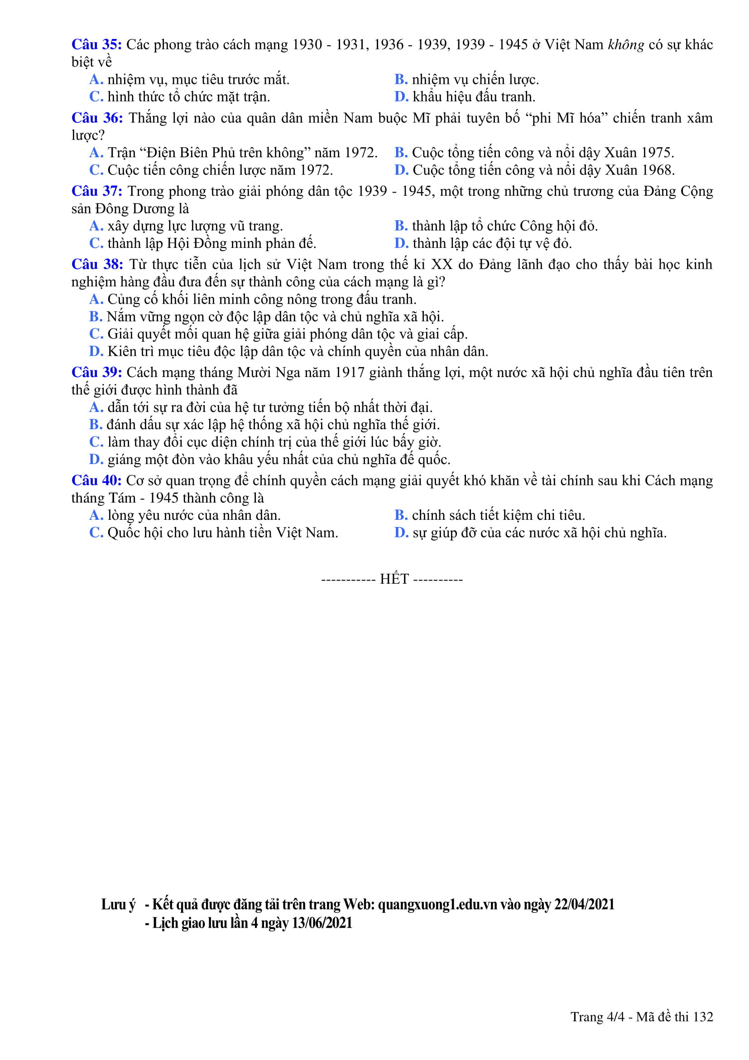
Câu | Đ/a | Câu | Đ/a | Câu | Đ/a | Câu | Đ/a
1 | B | 11 | C | 21 | D | 31 | B
2 | B | 12 | B | 22 | B | 32 | D
3 | C | 13 | D | 23 | A | 33 | C
4 | D | 14 | A | 24 | C | 34 | B
5 | D | 15 | B | 25 | D | 35 | B
6 | B | 16 | C | 26 | D | 36 | D
7 | C | 17 | C | 27 | B | 37 | A
8 | D | 18 | A | 28 | D | 38 | B
9 | A | 19 | B | 29 | C | 39 | C
10 | A | 20 | A | 30 | A | 40 | A

