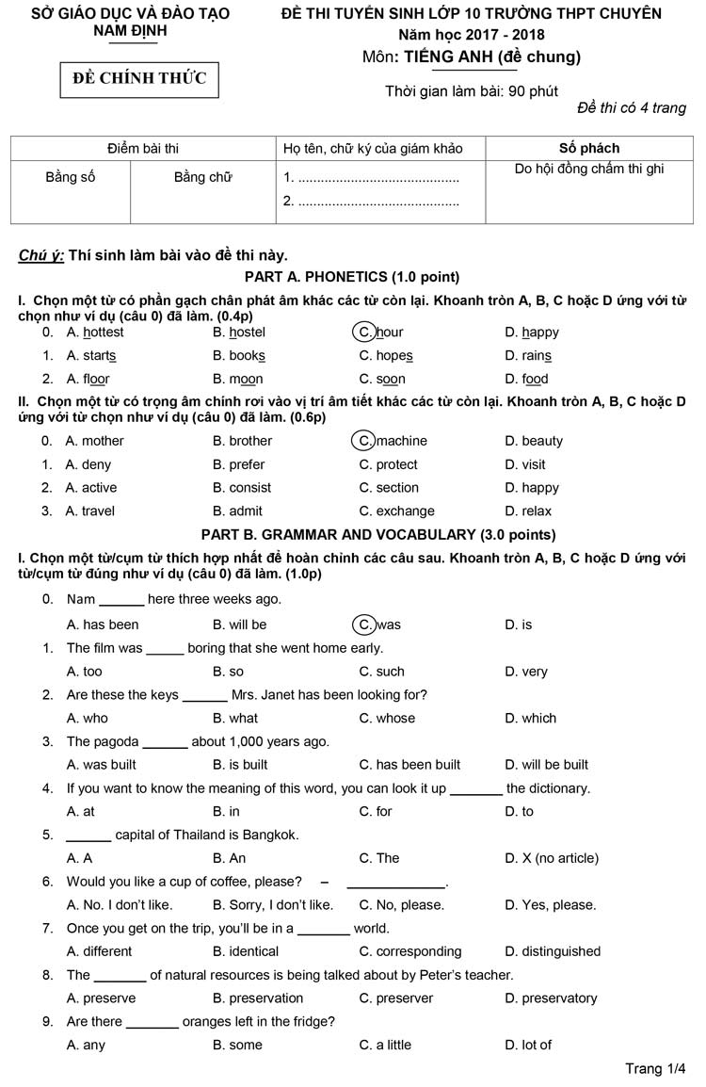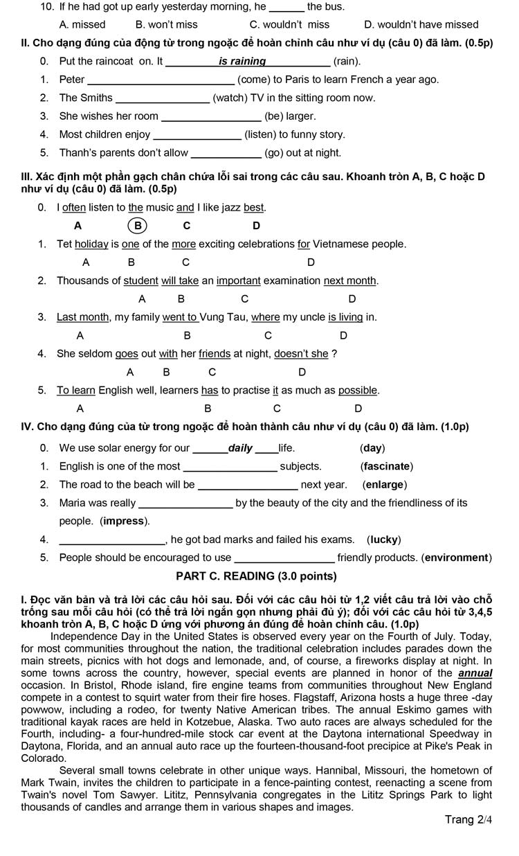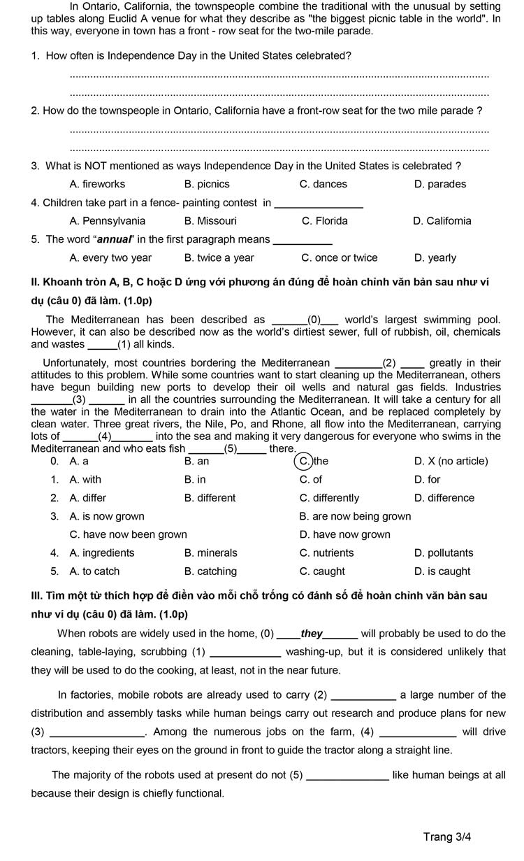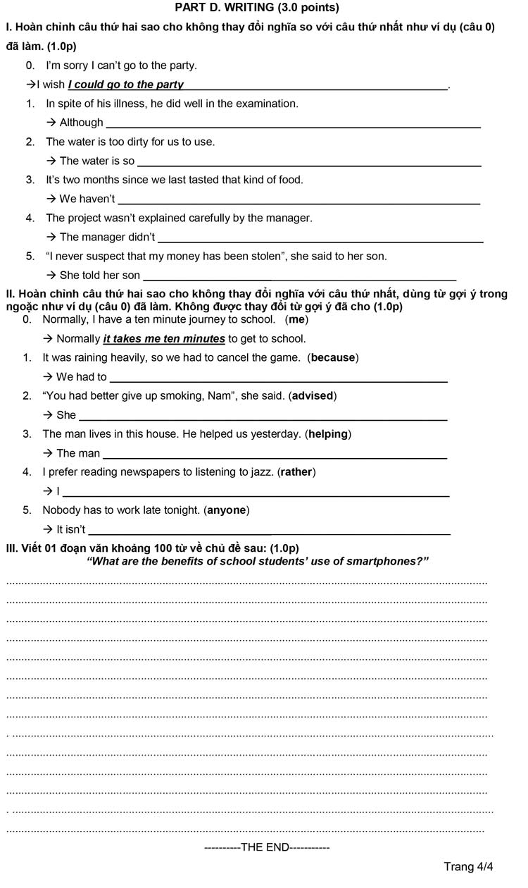
>> Đề thi năm tiếp theo:
- Năm 2018: Đề thi vào 10 môn anh chuyên Lê Hồng Phong 2018
- Năm 2019: Đề tuyển sinh lớp 10 môn Anh đề chung Lê Hồng Phong năm 2019

ĐÁP ÁN ĐỀ THI VÀO 10 2017 MÔN ANH - CHUYÊN LÊ HỒNG PHONG
PART A. PHONETICS (1.0 point)
I.
1. C - 2. A
II.
1.D - 2. B - 3. A
PART B. GRAMMAR AND VOCABULARY (3.0 points)
I.
1.B - 2. D - 3. A - 4. B - 5. C
6.D - 7. A - 8. B - 9. A - 10. D
II.
1. came
2. are watching
3. were
4. listening
5. going
III.
1. C - 2. A - 3. C - 4. D - 5. B
IV.
1. fascinating
2. enlarged
3. impressed
4. unluckily
5. environmentally
PART C. READING (3.0 points)
I.
1. (Independence Day in the United States/ It is celebrated) every year (on the Fourth of July).
2. ( The townspeople in Ontario, California/ They have a front-row seat for the two mile parade) by setting up tables along Eculid A venue for what they describe as “the biggest picnic in the world”.
3. C - 4. B - 5. D
II.
1.C - 2.A - 3.D - 4.D - 5.C
III.
1. and
2. out
3. products
4. robots/they
5. look
PART D. WRITING (3.0 points)
I.
1. Although he was ill, he did well in the examination.
2. The water was so dirty that we can’t use it/the water.
3. We haven’t tasted that kind of food for two/2 months.
4. The manager didn’t/ did not explain the project carefully.
5. She told her son (that) she never suspected that her money had been stolen.
II.
1. We had to cancel the game because it was raining heavily.
2. She advised Nam to give up smoking.
3. The man helping us yesterday lives in this house.
4. I would rather read newspapers than listen to jazz.
5. It isn’t necessary for anyone to work late tonight.
III.
Marking scheme:
The impression mark is based on the following scheme:
1. Format: (0.1 point for correct format). One paragraph only with the introduction, the body, and the conclusion.
2. Content: (0.4 point): a provision of main ideas and details as appropriate to the main idea.
3. Language: (0.3 point): a variety of vocabulary and structures appropriate to the level of secondary students.
4. Presentation: (0.2 point): Coherence, cohesion and style appropriate to the level of secondary students.
Trên đây là toàn bộ nội dung của đáp án đề thi tuyển sinh vào lớp 10 năm 2017 môn tiếng Anh đề chung đối với các thí sinh thi vào Chuyên Lê Hồng Phong (Nam Định).
Mong rằng những tài liệu của chúng tôi sẽ là người đồng hành hữu ích với bạn trong kỳ thi này. Đừng quên kho tài liệu đề thi thử vào lớp 10 môn tiếng anh của Đọc tài liệu bạn nhé!

